**DESIGN AND IMPLEMENTATION OF AN IOT BASED SMART GREENHOUSE MONITORING AND CONTROL SYSTEM**

**BY**

**OLUSHOLA,** JESUFERANMI SIMEON

(17CH023274)

**A PROJECT SUBMITTED TO THE DEPARTMENT OF COMPUTER AND INFORMATION SCIENCES, COLLEGE OF SCIENCE AND TECHNOLOGY, COVENANT UNIVERSITY OTA, OGUN STATE.**

**IN PARTIAL FULFILLMENT OF THE REQUIREMENTS FOR THE AWARD OF THE BACHELOR OF SCIENCE (HONORS) DEGREE IN MANAGEMENT INFORMATION SYSTEM (MIS)**

**JULY 2021**

# CERTIFICATION

I hereby certify that this project was carried out by **OLUSHOLA** Jesuferanmi in the Department of Computer and Information Sciences, College of Science and Technology, Covenant University, Ogun State, Nigeria, under my supervision.

1. Name: Dr. Iheanetu Olamma

**(Supervisor)**

Signature Date

1. Name: Dr. Oladipupo Olufunke

**(Head of Department)**

Signature Date

# dedication

This project is firstly and most importantly dedicated to the Almighty God for his eternal grace and unmerited favor. Indeed, he has been my ever-able rock and strength during this program. It was sincerely through his power that I successfully scaled through from the very start to the end.

I dedicate this report to my supportive parents, Mr. and Mrs. Olushola, for their unending help and guidance.

# acknowledgement

Firstly, and most importantly, I acknowledge the Almighty God for His support, His mercy, His grace, and His eternal favor throughout the creation to this my project.

I also acknowledge my parents, brothers, friends, and all who supported me for their continuous support and help.

I also acknowledge my supervisor Dr Iheanetu for being of so much help to me all through this project period.

I want to acknowledge the Department of Computer and Information Sciences' entire faculty and staff for their moral and academic guidance.

Finally, I would like to acknowledge all those who in one way or the other helped and supported me.

## table of content

CERTIFICATION 3

dedication 5

acknowledgement 6

table of content 7

list of figures 10

Abstract 11

Chapter one 12

Introduction 12

1.1 background information 12

1.2 Statement of the problem 14

1.3 Aims and objectives of the study 14

1.4 Methodology 14

1.5 Significance of the study 15

1.6 Limitation of the study 15

1.7 Project organization 16

Chapter two 17

Literature review 17

2.1 Introduction 17

2.2 Relevant associated terms 17

2.3 Machine to Machine Communication (M2M) 20

2.4 Internet of things (IoT) 21

2.5 Precision farming framework 26

2.6 Greenhouse Monitoring using Amtel Architecture 28

2.7 Greenhouse Monitoring using Arduino Architecture 30

2.8 Review of existing systems of iot in agriculture 32

2.9 Related findings 37

Chapter 3 38

3.1 introduction 38

3.2 system analysis 38

3.3 Optimum environmental conditions for greenhouse management 38

3.4 Analysis of Greenhouse Monitoring using Amtel Architecture 40

3.5 Analysis of Greenhouse Monitoring using Arduino Architecture 41

3.6 system design 43

3.7 system architecture 49

3.8 Logical design 50

chapter four 51

System implementation 51

4.1 introduction 51

4.2 system requirements 51

4.3 implementation tools used 52

4.4 Analysis of the IoT Prototype Implementation 54

4.5 program modules and interfaces 56

chapter four 60

summary, conclusion and recommendation 60

5.1 summary 60

5.2 conclusion 60

5.3 recommendation 60

references 61

# list of figures

Figure 2. 1:an esp8266 microcontroller 22

Figure 2. 4: arduino architecture 30

Figure 2. 5: arable data 33

Figure 3. 2: esp8266 44

Figure 3. 3: temperature sensor 44

Figure 3. 4: humidity sensor 45

Figure 3. 5: light intensity sensor 45

Figure 3. 6:soil moisture sensor 46

Figure 3. 7:led grow light 46

Figure 3. 8:circuit diagram 47

Figure 3. 9:blynk cloud 50

Figure 4. 1: iot connection 54

Figure 4. 2:arduino ide 56

Figure 4. 3:importing blynk libraries on the arduino ide 57

Figure 4. 4:setting up network in arduino ide 58

Figure 4. 5:blynk iot application 59

# list of tables

Table 2. 1:comparison of existing systems 38

Table 2. 2:analysis of amtel architecture 42

Table 2. 3:analysis of arduino architecture 43

# Abstract

Efficient management of greenhouse farming is a challenge to ensure high yield production. This is a great challenge to farmers who do not have a reliable mechanism to ensure the optimum environmental conditions for their crops. Farmers are opting to look for solutions from technologies such as Machine to Machine and Internet of Things.

An IoT prototype was developed to gather the critical environmental conditions in a greenhouse. The recorded data was transmitted by wireless networks using machine to machine (M2M) technologies from the sensors to the cloud platform, Blynk application dashboard, for real-time predictive analysis of the environmental parameters.

The IoT prototype was able to gather sufficient data and also able to control the ambient factors in the environment.

The result obtained from the prototype shows that Environmental conditions identified shouldn’t be only monitored but also controlled remotely is a critical necessity for ensuring greenhouse farming's success. As a result, IoT architectures should be used to monitor and manage a variety of environmental factors.

# Chapter one

# Introduction

## background information

The demand for food has been increasing daily as the worldwide population has increased. Greenhouses are used to cultivate crops in a controlled environment. Temperature, air humidity, light strength, soil moisture, carbon dioxide levels, and wind velocity are all regulated by experts, and these factors have an impact on productivity. A greenhouse aims to protect crops from extreme cold or heat, as well as unwanted pests. A greenhouse allows you to grow certain crops all year, including fruits, tobacco plants, vegetables, and flowers. A greenhouse garden is primarily meant to extend the growing season of prized crops and plants which requires it to be propagated in a controlled environment.

The goal of achieving high yield, high quality, and high-efficiency production is a problem in the study of greenhouse environment control(Shen et al., 2018). The need to provide a variety of environmental conditions for each plant has prompted researchers to employ a variety of monitoring systems. To overcome the challenges associated with the traditional greenhouse, the [automated greenhouse monitoring](https://www.iotconnect.io/smart-greenhouse-solution.html) and control system comes to the rescue. The rising ubiquity of technologies like the Internet of Things (IoT) is a key factor in the development of a connected greenhouse in the coming years.

A Smart Greenhouse provides advanced microclimate control and energy optimization. In a Smart Greenhouse Growers can:

* Monitor and control the parameters like luminosity, soil moisture, temperature, and Humidity.
* Modify an environment for their crops that increases crop quality by providing a climate-smart and nutrition-sensitive environment.
* Track and manage growth conditions.
* Automate the growing process.

## Statement of the problem

Environmental parameters in a conventional greenhouse can be regulated using a control system that requires manual intervention, which often results in increased labor costs, production loss, and energy loss.

Many farmers, however, are unable to reap the benefits of greenhouse crops and achieve the desired yield because they are unable to effectively track and regulate key factors that affect plant growth and productivity, such as light, air, and temperature.

## Aims and objectives of the study

The aim of this project is to design an IoT to improve crop production by monitoring and controlling factors (light, air, and temperature and soil moisture) that affect the production. The objectives of this project are:

* To identify the different environmental factors that enhance optimal crop growth.
* To design a Smart greenhouse monitoring and control system
* To implement and deploy a Smart greenhouse monitoring and control system

## Methodology

Materials such as journals, articles, conference proceedings, books, and research papers would be studied and reviewed, utilizing academic platforms and consulting library resources. Several models will be developed and designed in order to find the most fitting representation of the design and creation of a Smart Greenhouse monitoring and control system. Continuous monitoring of factors like humidity, light, temperature, soil moisture and CO2 gives relevant information pertaining to the individual effects of the various factors towards obtaining maximum crop production. The concentration will be the design and implementation for controlled climate conditions as well as controlling the various devices on production in this project. As data acquisition, various inputs (sensors) and outputs (motors) are mounted and connected to a PC through a controller circuit (ESP8266). To retrieve and show the state of the climate through sensing data, a graphical user interface will be used to view the data.

## Significance of the study

This project outlines the development of an IoT-based greenhouse monitoring and control system using ESP8266. Some of the previously developed systems used android devices to monitor the greenhouse but lacked control over it from remote locations. The most significant drawback of these systems was that one person had to be always present in the green house or close by.

The smart greenhouse system solves the first problem by removing the need for an individual to be always present in the greenhouse. The system will allow the farmer to make informed decisions by providing accurate information on the status of the sensors through the IOT web server connected to an IoT dashboard. As a result, this system enables farmers to manage their greenhouses from remote locations.

## Limitation of the study

The speed of an internet connection is an essential factor when using the app. It is important to have access to the internet via a wireless, or cellular network. The network is required to establish a communication link between the user's application and the hardware. The analysis will use a Live Agricultural Greenhouse Dataset derived from data feeds obtained from various integrated IOT sensors that will require internet communication to send data feeds on their attributes, with the following attributes being investigated for prediction: light intensity, soil moisture, humidity, and temperature. That way the data will be tested and see how the system functions.

## Project organization

**Chapter One:** This is the chapter aims at providing necessary background information to the research study. It also gives and insight to the solution approach of the problem and outlines the significance and limitations of the study.

**Chapter Two:** This chapter will focus on a detailed review of literature relating to the research study.

**Chapter Three:** This chapter will focus on the requirements of the system as well as its design. It will examine the system design in detail using tables, figures, and diagrams.

**Chapter Four:** This chapter will focus on the implementation of the already designed system in chapter three. It will also explain in the detail the overall system function, and how these functions are carried out.

**Chapter Five:** This chapter will focus on adequately summarizing previous chapter of the system and drawing a conclusion to the research project.

# Chapter two

# Literature review



## Introduction

This chapter focuses on a study of previous agricultural production prediction systems that have been developed. The study examines the various approaches used and implemented in ensuring precision agriculture, as well as the distinct impact that technology and the Internet of Things (IoT) have on the agricultural industry, their strengths, and validating methods. It also stresses the usefulness of each approach as well as the difficulties it faces.

## Relevant associated terms

This segment provides a summary of project-related terms and concepts.

### Internet of things

In the field of agriculture, extensive research on the Internet of Things (IoT) has previously been conducted. Because of the relationship between IT and agriculture, agriculture has taken on new directions. Liu and colleagues discovered that a growing number of companies in the United States (US) were investing in IoT Research and Development (R&D) and embedding data and sensors into their products(Saiz-Rubio & Rovira-Más, 2020). Via sensors and actuators, the IoT connects individuals, structures, computers, and technology. This overall integration of IoT with humans allows for real-time decision-making in terms of communications, collaboration, and technical analytics (Saiz-Rubio & Rovira-Más, 2020). “A dynamic global network system with self-configuring capabilities based on common and interoperable communication protocols, in which physical and virtual "things" have identities, physical characteristics, and virtual personalities, and use intelligent interfaces.”, and are easily incorporated into the knowledge network, communicating data associated with users and their environments on a regular basis.”(Liu et al., 2019) provides the most appropriate definition. IoT is a network of physical objects or items that have been fitted with sensors, programming, and other innovations to enable them to interact with other devices and frameworks through the Internet. Things have progressed because of a mixture of technological advances, analytics, artificial intelligence, item sensors, and embedded systems. Embedded systems, remote sensor organization, control frameworks, computerization (including home and building robotization), and other traditional fields all contribute to the IoT empowerment.

### Smart agriculture

Agriculture data is used to produce value in several ways, including livestock management, field crop plantation management, pesticide monitoring, and automated cattle gaze tracking services. Farmers may use web services, message services, and professional services. A user-friendly, web-based, or app-based control panel considers all the farmer's requirements across a wide range of services. This layer handles big data processing, which necessitates predictive analytics and multi-cultural analytics. The farmer will be aware of the field's potential climatic conditions, such as soil moisture, temperature, heat, light intensity, rain fall, and so on, in advance(FAO, 2013).

### Machine learning

An artificial intelligence application in which a machine can learn automatically from experience without needing to be specifically programmed. The emphasis is on computers' ability to use historical data and learn from it to forecast future data. It ensures that massive volumes of data are analyzed quickly and accurately, as instructed(Varone et al., 2019).

Machine learning can be categorized into the following:

* Supervised Machine learning: Machine learning algorithms that are supervised are designed to learn by doing. The term "supervised" learning comes from the fact that training such an algorithm is like having an instructor oversee the entire operation. It starts with the study of a training dataset, which results in an inferred feature that can be used to predict performance values; this is referred to as mapping. The algorithm can also differentiate between the expected and actual outputs using a test dataset, recognize errors, and retrain the model accordingly. Examples of algorithms are Help Vector Machines, Decision Trees, Logistic Regression, and Neural Networks(Varone et al., 2019).
* Unsupervised learning is the opposite of the preceding in that it makes use of unclassified or unlabeled data. It operates with the least amount of human supervision possible, with the aim of discovering patterns in the data or hidden mechanisms within the data. The algorithm will not find the actual output, but it will be able to infer it through data exploration. Clustering algorithms (k-means, hierarchical clustering), anomaly detection, and neural networks are examples of algorithms(Varone et al., 2019).
* Semi-supervised machine learning is a hybrid of supervised and unsupervised machine learning that trains on both labeled and unlabeled data. This method can improve learning accuracy, especially when a large amount of unlabeled data is combined with a small amount of labelled data. This method is commonly used due to the time and effort required to establish labels for a dataset, which typically necessitates the use of a professional human agent(Varone et al., 2019).
* Reinforcement Machine learning communicates with its surroundings by performing actions and identifying mistakes or rewards. It is characterized by delayed reward and trial and error search, allowing systems to decide the best way to act or infer with specific actions to perform at their best. The goal of this approach is to strike a good balance between discovering new territories and using what is already understood(Varone et al., 2019).

### IoT agricultural framework

Using IoT, the IoT agriculture system caters to full-fledged agricultural innovation (This is accomplished using sensors and actuators). This layer includes the Internet and other similar networking technologies. Examples of innovations include Wireless fidelity (Wi-Fi), Global System for Mobile Communications (GSM), Code Division Multiple Access (CDMA), and Long-Term Evolution (LTE) (4G). Sensing, actuating, and disease identification services include sensor data collection, equipment detection, crop disease data storage, and statistical analysis(Ray, 2017).

### Data mining

Data mining is a technique for identifying variations, associations, and similarities in large datasets to predict outcomes or goals. It is commonly used in a variety of fields to raise sales, cut costs, improve customer experience, and reduce the risks associated with the industry. Although the word has a long history, it was not invented until the early 1990s. Statistics, artificial intelligence, and machine learning are all interconnected. Data mining has aided in the automation and user-friendliness of activities that were previously manual and time-consuming. This is being used by a variety of industries, including education, banking, social media, telecommunications, manufacturing, and so on, to promote growth in their respective fields(*Liu et al*., 2019).

## Machine to Machine Communication (M2M)

M2M (machine-to-machine communications) refers to technologies that allow devices to communicate with one another across wired and wireless networks. Sensors are used in M2M to record weather conditions, which are then sent to an application software program via a wired or wireless network. (Maina, 2016).

M2M has been employed in a variety of industries, including health care, where it is used for remote patient monitoring to obtain heart rate and glucose levels. It works by connecting a monitoring equipment to a mobile phone via Bluetooth. In the transportation industry, a sensor that uses mobile communications is installed in the vehicle and is utilized for a variety of activities, including fleet management, theft prevention, and navigation, which provides video map information to the vehicle. The falling costs of devices, connectivity, and the global deployment of the internet are the main drivers for M2M solutions adoption(Maina, 2016).

Advances in radio technology and wide-area communication protocols have resulted in lower communication costs, allowing M2M deployments to expand. Because the Internet has become the de facto standard for network communications, most communication service providers throughout the world are deploying IP networks on a national and worldwide scale(Saiz-Rubio & Rovira-Más, 2020).

## Internet of things (IoT)

The IoT is a network of physical objects or items that have been fitted with sensors, programming, and other technologies to enable them to communicate with other devices and frameworks through the Internet. Technological developments, analytics, artificial intelligence, item sensors, and embedded systems have all led to development. The IoT is empowered by embedded devices, remote sensor organization, control mechanisms, computerization (including home and building robotization), and other conventional fields.

### IOT SMART OBJECTS: HARDWARE AND SOFTWARE

1. IoT Hardware

IoT hardware includes components such as routing modules, bridges, sensors, and other IoT hardware. System activation, security, action specifications, communication, and identification of support-specific objectives and actions are just some of the tasks and functions handled by these IoT devices. The IoT is a network of connected devices through a Single-board processors, such as the Arduino Uno; low-power sheets, which are basically smaller sheets that are connected to mainboards to improve and grow their utility by carrying out explicit capacities or features, are examples of hardware parts that can change (like GPS, light and warmth sensors, or intelligent showcases). A software engineer constructs a circuit configuration to show the relationship between these data sources and yields after deciding the information and yield of a board.

1. Espressif’s ESP8266EX delivers highly integrated Wi-Fi SoC solution to meet users’ continuous demands for efficient power usage, compact design and reliable performance in the Internet of Things industry. With the complete and self-contained Wi-Fi networking capabilities, ESP8266EX can perform either as a standalone application or as the slave to a host MCU. When ESP8266EX hosts the application, it promptly boots up from the flash.

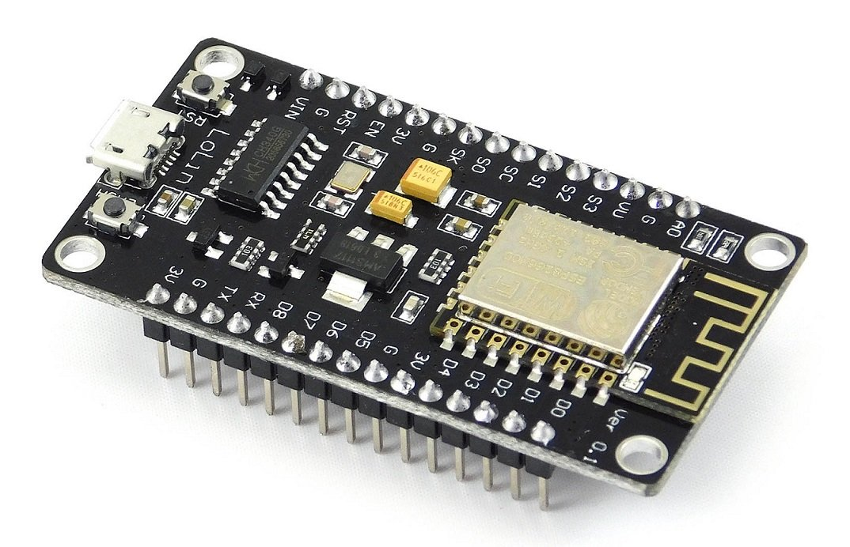

Figure 2. :An ESP8266 microcontroller (Systems, 2020)

1. The Raspberry Pi 2, a low-cost, small computer that can run a full web server, is a popular IoT platform. Since it has enough processing power and memory to run both Windows 10 and IoT Core, it's known as "RasPi." When programming in Python, the RasPi has excellent processing capabilities.
2. IoT software

IoT applications and programming languages are commonly used and well-known programming languages by programmers. Because of their lower storage and processing power, embedded systems, for example, have different language requirements. The most frequently used embedded operating systems are Linux or UNIX-like operating systems, such as Ubuntu Core or Android. IoT applications can be written in a range of languages, from general-purpose languages like C++ and Java to embedded-specific languages like Google's Go or Parasail.

Some IOT Software languages are as follows:

1. IoT applications and programming languages are commonly used and well-known programming languages by programmers. Because of their lower storage and processing power, embedded systems, for example, have different language requirements. The most frequently used embedded operating systems are Linux or UNIX-like operating systems, such as Ubuntu Core or Android. IoT applications can be written in a range of languages, from general-purpose languages like C++ and Java to embedded-specific languages like Google's Go or Parasail.
2. b. Java: JAVA code is more versatile than C and C++ code, which are hardware specific. It's more of a write-once, read-anywhere language, where you install libraries, write code once, and then you're good to go.
3. c. Python: Python's popularity has recently grown, and it has now developed itself as one of the "go-to" languages for Web development. Its use in embedded control and IoT is steadily gaining popularity, thanks to the Raspberry Pi processor. Python is an easy to read, understand, and write interpreted language. It's also a force to be reckoned with when it comes to data-intensive applications.

### Challenges Facing Internet of Things

According to (World, 2015) IoT has the following challenges when it comes to its deployment:

1. Every IoT application requires stable broadband connectivity to allow device interaction, data exchange, storage, analysis, and response to real-world events.
2. In the deployment of IoT applications, security and privacy are important concerns. Information can be intercepted at several stages, including at the nodes as they exchange data, as well as when sending or receiving data in the cloud or at cloud storage.
3. Because IPv6 addresses have a huge addressing capacity, they must be adopted at a faster rate for IoT to be implemented successfully.
4. To form connections and facilitate big data exchanges, IoT devices signaling and sending data to one another require low power consumption.

### IoT Use Cases

**Health care:** Whether it's a handheld computer gathering patient details at an emergency room visit or a diabetic's on-body continuous glucose monitoring system, IoT devices at the edge are transforming patients' healthcare experiences. From heart and blood pressure sensors to “smart” pills equipped with a time-release or electroceuticals that track intake to wearables like smart socks with temperature control or smart vests for vital sign tracking, we're beginning to see all sorts of IoT devices gathering health data from individuals. Aside from clocks, there are a variety of devices that advise patients to correct their posture and take their medications(Grunwald et al., 2011).

**Supply chains:** Another application of the IoT is in supply chains, which are becoming increasingly global and complex. Customer demands change constantly, goods must be ordered, and shipping and distribution routes must be coordinated. As a result, businesses are putting together interconnected enterprise structures and using data modeling as part of a larger data management strategy. Low-power IoT devices are also being used to track properties in the supply chain and control product quality parameters such as temperature and vibration, as well as to track shipping container openings. Route planning can be enhanced further by collecting in-transit supply chain data using IoT-enabled devices on transportation routes(Tzounis et al., 2017).

**Building and Home Automation:** IoT instruments can be used to track and control the mechanical, electrical, and electronic frameworks used in different types of structures in home computerization and building mechanization frameworks (e.g modern, foundations, or residential, private, and public).

### IoT Platform

Without an IoT platform, every IoT product would be incomplete. It will assist you in reducing time to market, reducing risk, lowering production costs, and achieving product-market fit. The IoT platform is a collection of technologies that you can use to create your product on top of. IoT platforms have the "infrastructure" you'll need to create the unique features of your solution. The aim of an IoT platform is to provide all your app's common functionality so you can focus on creating features that differentiate your product and offer value to your target audience.

The following are some of the features of an IoT platform:

1. Sensors gather real-world data, and the system connects to the cloud to send and receive commands.
2. Data storage in the cloud
3. Data research on the cloud to gain insights
4. Use observations to command the "stuff" to perform tasks.

### The Internet of Things architecture

The architecture of an IoT system is divided into three levels:

Tier 1: Devices,

Tier 2: Edge Gateway,

Tier 3: Cloud

Some experts refer to the three levels of the IoT system as edge, point, and undertaking, and they are linked by a proximity organization, an access organization, and an administration organization. The network of things, which is based on the IoT, is a data intermixing engineering for the application layer of the IoT. To build innovative use-cases, IoT devices are being transformed into Web applications. A new architectural path called BPM Everywhere is being established to program and track the flow of data in the IoT. It blends conventional cycle executives with data mining and unusual capacities to automate the control of vast quantities of connected devices.

## Precision farming framework

A Wireless Sensor Network (WSN) system, according to Blackmore et al. (1994), can be created to improve the quality of agricultural production by appropriately monitoring soil and the environment. Farmers were also hesitant to adopt WSN in its early stages due to its high cost, according to the researchers(Maina, 2016).

However, the cost of technical research and deployment has decreased over time. Over the last 15 years, advances in digital electronics and telecommunications infrastructure have resulted in computers that are faster, cheaper, and smaller. As a result, embedded devices having network interfaces have been developed. Precision agriculture technology are primarily used to assist farmers in making educated decisions. Farmers can also access previous data from the maps' numerous layers of data, which improves the quality of management decisions and recommendations. Effective decision-making, on the other hand, is dependent on the accuracy and timeliness of the data collected (Maina, 2016).

### Advantages of the precision farming framework

According to (Maina, 2016) the following are the advantages of precision farming framework

1. Due to improved monitoring, the quality of agricultural produce improves, resulting in better profit margins.
2. It provides a framework for a wireless sensor network that allows for efficient access to farm data.
3. It provides for improved farm management using high-input mechanisms like sensors that record environmental variables and GPS that allows fields to be readily inspected.

### Disadvantages of the precision farming framework

According to (Maina, 2016) the following are the advantages of precision farming framework

1. The integration of multiple systems, such as sensors, GIS, and GPS, necessitates a significant reliance on Internet connectivity.
2. Because of the time necessary to gather and analyze the data needed, it may take years to completely deploy this system fully.
3. In undeveloped nations, adoption rates are low due to a lack of knowledge among farmers about technical advancements.

## Greenhouse Monitoring using Amtel Architecture

Microcontrollers and relays are used in greenhouse monitoring projects to monitor and regulate environmental variables including as humidity, temperature, pH, and soil moisture. The parameters are established in accordance with the vegetables or fruits that will be cultivated in the greenhouse. Temperature and light were chosen as the factors to be monitored in this Amtel design. As a result, they employed the appropriate sensors, such as temperature and light(Maina, 2016).

To monitor and regulate environmental conditions, the project employs an Amtel microprocessor. Monitoring entails reading analog values in milivolts to determine environmental conditions. As a result, an amplifier is required to transform the milivolts to volts before the values can be digitalized.

The Analog to Digital Converter (ADC) transforms analogue environmental factors read by sensors into digital values that the microcontroller may use to accomplish its tasks.

When these parameters exceed the Amtel microcontroller's specified level, the controlling action is taken. Motor drivers are the controlling devices in use. Motor drivers' outputs are utilized as buzzers to alert people.

The Liquid Crystal Display (LCD) is used to display the microcontroller's findings at a given moment, such as the values that have been converted from analog to digital and the commands issued to the motor drivers.

### Advantages of greenhouse monitoring using Amtel architecture

According to (Maina, 2016), the advantages of the Amtel Architecture in greenhouse monitoring are as follows :

1. This design greatly decreases the amount of human work needed to monitor and regulate environmental variables and parameters.
2. The design may be used in a greenhouse to monitor and manage the environmental conditions of various plants as part of an Agriculture Management System (AMS).
3. The data gathering procedure for environmental variables that regulate the growth of various plants cultivated in a greenhouse, such as flowers, vegetables, and fruits, has been automated.

### Disadvantages of greenhouse monitoring using Amtel architecture

According to (Maina, 2016) the advantages of the Amtel Architecture in greenhouse monitoring are as follows:

1. The architecture only monitors a few environmental factors, such as temperature and light, and ignores other essential factors such as humidity, soil PH levels, and so on.
2. It takes a lot of technical training and assistance for successful deployment of the system.
3. The Amtel microcontroller is not a powerful microcontroller since it uses relatively little power, necessitating the usage of a 12-bit Analog to Digital Converter (ADC). Furthermore, it has a limited level of integration with other components, such as sensors, and hence cannot handle many sensors.

## Greenhouse Monitoring using Arduino Architecture

Many factors are measured in this design to monitor and regulate the quality of plants produced in greenhouses. Temperature, humidity, light intensity, and soil moisture are the variables, as shown below in figure:

Figure 2. : Arduino architecture(Maina, 2016)

The arduino microcontroller is at the center of this design. It continuously converts the analogue to digital signals from the different sensors, validates them, and determines whether any remedial action is required at that moment. As a result, the arduino microcontroller performs its monitoring and regulating duties in this manner. When the temperature rises over a certain threshold, the Arduino microcontroller activates the temperature control relay, which in this case is a fan. It is also switched off automatically when the temperature falls into the usual range (Maina, 2016).

The arduino microcontroller monitors the humidity levels recorded by the sensors, and when the humidity in the environment falls below the preset limits, the moisture spraying motor is automatically switched on and off until the required level is reached. When the light intensity falls below a certain threshold, the arduino microcontroller turns on the light bulbs, and when the light intensity rises to the desired level, a motor turns off the light bulbs.

When the arduino microcontroller automatically switches on or off the corresponding motors to manage the ambient conditions, a GSM modem has been integrated in this design to send a notification to the system's owner (Maina, 2016).

### Advantages of Greenhouse Monitoring using Arduino Architecture

According to (Maina, 2016) the following are the benefits of utilizing Arduino architecture to monitor greenhouses:

1. Any sensor or motor that fails will only affect a particular function of the system, not the whole system.
2. The user is notified of any changes made by the motors controlled by the Arduino microcontroller through the GSM Modem.
3. Low-cost system, low-power consumption, low-maintenance, and automated data gathering employing high-sensitivity, easy-to-handle sensors.

### Disadvantages of Greenhouse Monitoring using Arduino Architecture

According to (Maina, 2016) the following are the benefits of utilizing Arduino architecture to monitor greenhouses:

1. To work properly, it requires an uninterrupted power supply, which may necessitate the use of an external power source such as batteries.
2. There is no internal system for detecting sensor or motor failure.
3. In terms of an agricultural management system, complete automation is not possible. Pest and bug identification and removal, for example, may be difficult to perform.

## Review of existing systems of iot in agriculture

As previously stated, the goal of this research is to determine how IoT-based technologies can be used in agriculture. A search of methodology by was conducted in order to attain this goal.

### MotorLeaf from Canada

MotorLeaf from Canada: MotorLeaf, based in Canada, is a pioneer in the advancement of agricultural technology. MotorLeaf is an agricultural IoT platform that helps farmers control crop yield and quality. Artificial intelligence enables them to create automatic greenhouse technologies. Farmers will use this technology to make data-driven decisions on how to grow their crops. The technology was created with hydroponic greenhouses in mind. When opposed to soiled agriculture, hydroponics has many advantages. Fertilization, spraying, and over-irrigation are not needed in a Soilless greenhouse. Since plants are less likely to be afflicted by diseases, they develop healthier. It is possible to obtain goods continuously in indoor environments throughout the year using a hydroponic greenhouse. The agricultural sector will be able to provide deserts, cold areas, and possibly one day, nutrients on Mars, thanks to this scheme(Shirsath et al., 2017).

### Arable

Arable: Arable began full product launch in 2016 with the goal of improving human health, economic prosperity, environmental footprint, and the lives of agricultural workers by improving the food system through access to high-quality data. To expedite data collection, Arable employs a Gridded Weather combination model. More than 40 weather and plant measurements are tracked by Arable to provide detailed insight into climate variability, crop health, and the decisions that these factors influence, such as event timing and irrigation. Data from arable devices can range from regular weather to advanced plant sensors, which can be used to forecast disease, water and nutrient needs, and even potential crop yields. The business will run predictive analytics with this data to keep producers updated and prepared. Users can set up their system and begin accessing data as soon as they take their devices out of the box, thanks to Arable. Farmers can scenario plan more effectively now that they have more knowledge at their fingertips. They are better at planning ahead and managing capital. Even the most remote agricultural villages benefit from Arable's global network and cellular-connected devices, which provide real-time data on climate, weather, crop health, and yields. Farmers and their communities can use predictive analytics with this information. Arable looked at Cyclone Enawo in Madagascar in 2020 and its influence on vanilla output, as well as fire-affected wineries in Napa and a coffee leaf rot outbreak in the previous nine months. On a worldwide cellular network, Arable performs a microclimate-specific field analysis on over 40 data streams to provide ground-truth accuracy(Verdouw et al., 2016).

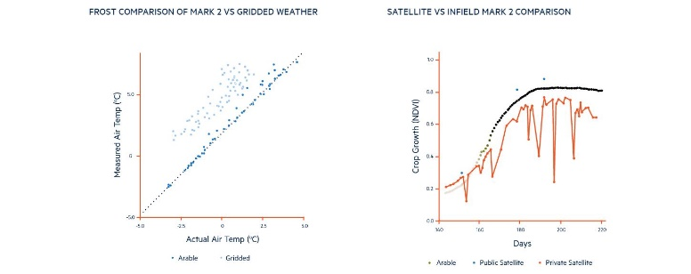

Figure 2. : Arable data (*Verdouw et al.*, 2016)

Arable generates, analyzes, and computes agricultural data using Realtime computations from actual air temperature using Frost Comparison and Satellite Geo-mapping.

### Gamaya

In order to meet the requirement that 10 billion individuals be taken care of, Gamaya, a Swiss startup dynamic in brilliant cultivation, creates special farmed diagnostic administrations for modern farmers in Brazil, using licensed innovation image advancement to collect all physiological data and the most effectively synthetic organisation. Early detection of illness and bugs, identification and diagnoses of stress (mechanical damage, supplement insufficiency, water pressure, soil compaction), monitoring of development for streamlining of preparation, as well as yield anticipation are all examples of our central contribution. Gamaya has been recognized by Forbes as one of the 4 European AgriTech new startups having a chance to convert into a $1 billion dollar company. By offered compelling sophisticated agriculture and powered by far-reaching detection, super-spectral imaging, and human awareness, Gamaya improving the efficiency and maintainability of the produce creation. To maximize costs and reduce environmental effect, Gamaya employs several crop inputs and values(López-Lozano et al., 2015).

Gamaya focuses on three main elements of its processes:

#### Collecting data

Gamaya uses remote sensing pictures collected by drones, aircraft, and satellites, as well as historical climate and meteorological data, to collect data from your fields. Gamaya collects data on which plants represent various quantities of green and NIRS light using drones. This data is used to produce multispectral pictures that may be used to track the health of crops. Crops can be salvaged if they are properly checked, and any faults are detected as soon as possible. Gamaya uses unmanned aerial vehicles to help with crop processing, crop growth monitoring, and other agricultural tasks.

#### Crop data analysis

Gamaya's technique analyzes data for crop, variety, and region-specific knowledge on agricultural technology and physiological characteristics using comprehensive crop models and artificial intelligence.

#### Geo-mapping

Gamaya's research yields useful maps that depict real-world agronomic issues including nutrient shortages, disease infections, and insect and weed infestations. Gamaya's innovative geo-mapping approach ensures that maps describe and address farming concerns depending on numerous environmental parameters.

### Mothive

Mothive: Mothive is an automated agronomy service that helps farmers raise yields, minimize waste, and improve crop predictability and control. The Mothive Ladybird is a one-of-a-kind device that offers farmers a simple, cost-effective, and turnkey solution for lowering risk and rising crop value. Based on real-time crop needs, the machine forecasts pests, increases yields, and automates farm activities, as well as predicts and advises farmers on the best time to harvest and other logistics.

Mothive collects data using novel terraprima sensors that are mounted next to the plants to collect environmental and soil data. This terraprima sensor has been custom configured by mothive to improve sensing performance and data accuracy. Mothive effectively uses bespoke Machine Learning models to predict crop growth conditions, pests, and the crop harvest for crop prediction and analysis. The GNB inference algorithm was implemented as an NFPE by Mothive's novel Bespoke Machine Learning Model processor. The mothive information track system ensures that suggestions and warnings are sent out correctly via dashboard, SMS, and email.

Mothive focuses their services on these three main crops:

* Viticulture: Mothive improves crop security and productivity for your vineyards by properly forecasting frost and other climatic conditions. This connects pre-harvest and post-harvest processes, resulting in a more efficient growth process.
* Soft Fruit: For a range of soft fruits, Mothive uses GDH, GDD forecasts, and tailored crop and variety specific models and algorithms. This was done to assure proper input savings, disease reduction, increased yields, and improved fruit quality.
* Top Fruit: Mothive employs a set of decision-making tools tailored to Top Fruit farmers. This ensures enough efficiency in connecting both pre- and post-harvest circumstances, allowing the food supply chain to run more efficiently.

### Comparison of Existing Systems

Table 2. :Comparison of Existing Systems

|  |  |  |  |
| --- | --- | --- | --- |
|  | Arable | Mothive | Gamaya |
| IOT  Device  Compatibility | Targeted at relatively small to medium-sized farms | Targeted at small and growing farms | Designed for Large-Scale Farms |
| User Experience | Poor User Interface (UI) layouts design. Hardly any training is required to operate the application | Some users might need to be trained on how to use the system (Slightly complicated UI) | Good user interface design. Users may need minimal training on how to use the application. |
| Data Transfer | Automated | Automated | Manual |
| Software Features | Tailored customizations for farms, enables customization in farm administrations. |  | Rigid Software structure |

## Related findings

The fundamental goal of IoT deployment is to use the Internet to connect devices and sensors to monitor and manage not just environmental conditions but also smart things. The Internet is a critical technology that serves as the foundation for IoT infrastructure development.

It was clear that technologies exist to implement IoT infrastructure in agriculture. Furthermore, it has the potential to make a significant impact for farmers in terms of monitoring conditions, resource conservation, cost control, and overall efficiency.

The fact that certain notable models and attributes have been used in a variety of methods does not negate the fact that there is still space for change or advancement of other models. Finding the right attributes to predict Plant output can never be exhausted in today's environment, as new attributes correlating with varying crop performance of Plants are investigated daily.

Since it was commonly used and had high precision, the method proved to be the best method for forecasting crop output over a wide variety of crops. It was also the best option due to its high degree of interpretability. This isn't to suggest that other approaches can't be used; they certainly can, nonetheless, how they are used varies depending on the study target.

# Chapter 3



## introduction

To create the overall system, this chapter provides a full explanation of the different components used, as well as their purposes. There's also a lot of explanation on why some components were chosen over others. The tools and techniques used, as well as the logic and sequential flow architecture used by the system's control and processing unit, were used to achieve the desired result.

## system analysis

It's a set of actions that clarifies or simplifies the duties and functionalities that a new system should do and have. Among other things, system analysis may entail looking at how a software product or package is used by end users; an in-depth examination of the source code to define the methodologies used in software development; or conducting feasibility studies and other types of research to support the use and production of a prototype.

## Optimum environmental conditions for greenhouse management

Temperature, light, humidity, water, and carbon dioxide are the most critical environmental factors to regulate for an optimum greenhouse climate. The most essential factor in greenhouse farming operations is temperature, which has a considerable impact on plant growth and development. Temperatures in small-scale greenhouses should be kept between 16 and 30 degrees Celsius during the day and 13 to 18 degrees Celsius at night. Plant development is inhibited when temperatures are too low, but plant withering and death occur when temperatures are too high(Maina, 2016).

Controlling humidity is also important for plant growth. The ideal relative humidity level is between 50 and 70 percent. Humidity that is too low hinders plant development, but humidity that is too high stimulates mold growth, which causes plant illnesses.

Through the photosynthesis process, where plants mix CO2 with water to generate oxygen and carbohydrates, the CO2 concentration in a greenhouse has a significant impact on plant growth rate. For most plants, the optimal CO2 concentration is around 1000 ppm (parts per million), but photosynthesis may reduce it to 200 ppm, which is low enough to severely influence plant development.

Water is also essential for plants in a greenhouse, mostly for irrigation, which allows for transpiration and photosynthesis. The loss of water from plants in the form of vapor is known as transpiration. This mechanism is necessary for plants to avoid wilting in hot, sunny conditions. The process through which plants produce food is known as photosynthesis. Water is essential in these 33 processes because it passes through the plant's stem and on to the leaves, where photosynthesis occurs.

Light is another essential environmental factor; they typically get their energy from sunshine in order to perform photosynthesis. Plants can't create the energy they require to grow if they don't have access to light.

As a result of this knowledge, inputs were made able to set a threshold for the prototype to monitor the ambient factors.

## Analysis of Greenhouse Monitoring using Amtel Architecture

This greenhouse monitoring study was carried out after researching the literature to see how the characteristics of the Amtel architecture handle the difficulties of greenhouse management. As seen in the table, the architecture is inadequate, necessitating the construction of a more robust structure.

Table 2. :Analysis of Amtel Architecture(Maina, 2016)

|  |  |
| --- | --- |
| Challenges facing greenhouse monitoring | Characteristic of Amtel Architecture |
| High operational cost | Operational Costs are Exorbitant the Amtel Microcontroller, Analog-to-Digital Converter, LCD screen, and motor drivers that function as actuators are all expensive components. |
| Monitoring and controlling environmental conditions | Only monitors and regulates light and temperature, leaving out other critical elements like humidity and soil moisture. Furthermore, the device does not send information to farmers through the internet. |
| Pests and Diseases | There isn't a sensor that detects insect movement. |

## Analysis of Greenhouse Monitoring using Arduino Architecture

This greenhouse monitoring study was carried out by looking through the literature to see how the characteristics of the Arduino Architecture for greenhouse monitoring handle the difficulties of greenhouse management. As seen in the table, the architecture is inadequate, necessitating the construction of a more robust structure.

Table 2. :Analysis of Arduino Architecture(Maina, 2016)

|  |  |
| --- | --- |
| Challenges facing greenhouse monitoring | Characteristic of Arduino Architecture |
| High operational cost | It's a pricey system that calls for an Arduino microcontroller, sensors, an LCD screen, and GSM Modemand motor drivers to function as actuators. |
| Monitoring and controlling environmental conditions | Environmental factors like as temperature, humidity, light intensity, and soil moisture are monitored and controlled. In addition, the technology sends farmers SMS notifications. |
| Pests and Diseases | Does not have a sensor that can detect pest movement or bacterial invasion on the plants. |

### Requirement analysis

Any system's system requirements are a description of what that system should accomplish, including the services it will provide and the limitations on its functioning.

### Functional requirements

* Users can view analytics on performance of their Crops
* Users can view data from the sensors in the greenhouse
* Users can see abnormalities from sensor readings
* Users can control actuators in respect to sensor readings

### Nonfunctional requirements

A system's non-functional requirements are concerned with setting constraints for how the functional requirements should be executed precisely.

* Everyone should be able to understand the interface
* The data of users should be protected from all types of security threats.
* The interface should be accessible from anywhere there’s internet connection

## system design

It's the process of establishing a system's architecture, interfaces, modules, components, and data to meet certain requirements. Getting the final solution approach to a challenge is crucial to designing. Its purpose is to describe how an input flow will result in each output.

To ensure the project's success, the system incorporates both software and hardware design principles in designing the smart greenhouse system. Some of the hardware components, on the other hand, are pre-assembled peripherals that may be simply interfaced and programmed with the ESP8266 Microcontroller.

### Physical Design

All the physical components required to finish the project are included in the hardware design. It goes over the design specifications for each component as well as how they're connected to ensure the system works properly.

#### ESP8266 Microcontroller

The microcontroller is regarded as the brain of the whole project. It's in charge of executing the logic essential for the project to work well. It has direct connections to all the project's hardware components. Figure:

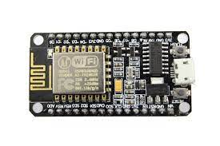

Figure 3. : ESP8266*(Systems, 2020)*

#### Temperature Sensor

If the temperature rises beyond the stated limit, a fan will automatically turn on as a coolant to lower the temperature. With the help of a relay, the fan will be turned off automatically once it reaches the specified temperature. If the temperature falls below the optimum level, a bulb will be turned on as a heater to keep the temperature within the required range.

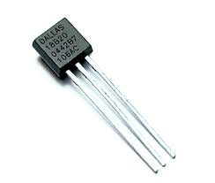

Figure 3. : Temperature Sensor*(Verdouw et al., 2016)*

#### Humidity Sensor

The humidity sensor detects the vapours in the air. The display of values would be affected by changes in the RH (Relative Humidity) of the environment.

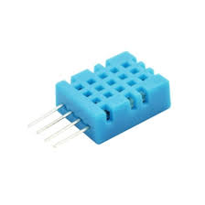

Figure 3. : Humidity sensor(*Shirsath et al.,* 2017)

#### Light Intensity Sensor

In the visible light range, the light sensor is particularly sensitive. When the surrounding natural lighting are low, the light sensor coupled to the system shows the data values.

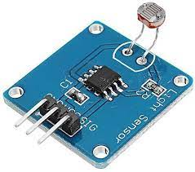

Figure 3. : Light intensity sensor*(Shirsath et al., 2017)*

#### Soil Moisture Sensor

The sensor probes are the two copper leads. They're submerged in a sample of soil whose moisture content is being measured. Soil conductivity is determined by the quantity of moisture in the soil. It increases when the soil's water content rises, forming a conductive route between two sensors probes that leads to a close path that allows current to pass.

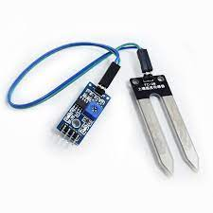

Figure 3. :Soil Moisture sensor(*Shirsath et al.,* 2017)

#### LED grow light

Artificial lighting in a greenhouse provides a variety of advantages to plants by serving as a supplement during the winter months when natural light hours are limited, during unusual seasonal changes, or simply when solar radiation is insufficient.

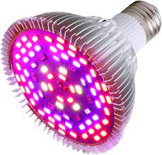

Figure 3. :LED grow light(*Shirsath et al.,* 2017)

#### Component connection

Figure 3. :Circuit Diagram

### Software Design

#### Arduino Integrated Development Environment (IDE)

To write projects and upload them into the ESP8266 board, the Arduino software (IDE). The programs developed using the Arduino IDE are known as sketches because of their simplicity. They are, at their core, text files written in the Arduino programming language. The .ino file will be saved and uploaded to the Arduino board.

#### The Arduino programming language

The Arduino programming language is divided into three sections. First and foremost, the individual will have control functions for the board. Characters me be analyzed, mathematical calculations may be conducted, and do a variety of other things with functions. For example, digitalRead() and digitalWrite() allow the programmer to read or write a value to a specific pin.

Every sketch written in the Arduino language comprises two functions. setUp() and loop() are the two methods . A sketch always begins with setUp(), which is called once after the board is powered up or reset. After it has been created, a loop() may be used to continue the program until the board is turned off or reset.

The Arduino values, which represent constants and variables, are next. The majority of the data types (array, bool, char, float, and so on) are C++ like. Programmers can also conduct type conversion. Structure is the last section of the Arduino language. Small code elements, such as operators, are included.

#### Syntax requirement

The syntax is very similar to that of C++. The use of curly braces to surround the code blocks is the first resemblance that would be noticed. The system will throw an error if forget to close a curly brace after utilizing the opening one. Thankfully, if you click on the opening brace in the Arduino IDE, the closing brace will be highlighted, making it a simple task to inspect. Semicolons must be used to finish statements in Arduino, just as they are in C++. When one is missing, an error is triggered.

Another obvious resemblance is the way comments are entered. Depending on whether the programmer require a single-line or a block comment.

#### The blynk iot platform

Blynk is a Platform with IOS and Android apps to control Arduino, Raspberry Pi and the likes over the Internet. It’s a digital dashboard where individuals can build a graphic interface for a project by simply dragging and dropping widgets. Blynk is essentially an app editor. One or many projects can be made using it.

Each project may include graphical widgets such as virtual LEDs, buttons, value displays, and even a text terminal, as well as the ability to interact with one or more devices. It is possible to control Arduino or ESP8266 pins straight from a phone using the Blynk library, without having to write any code.

It's also possible to share a project with friends or even clients, allowing them to access the linked devices but not edit it. A can share the project with other members of the family or work environment so that they can use the features as well.

#### The blynk microcontroller libraries

A Blynk library that targets a device and connectivity type combination is used to implement the support. The physical pins that are part of the Microcontrollers hardware, as well as the virtual pins that are implemented in software by the Blynk Platform, would be used in the sketches.

#### The blynk application features

1. A notifications service can be created using the Blynk app without using any third-party platform like [IFTTT](https://iotdesignpro.com/tags/ifttt). Data can be posted when a sensor reaches its threshold. This can be possible just by configuring the Blynk app.
2. In IoT projects, the hardware part is easy as compared to the software part. But using Blynk, the software part also becomes easier than the hardware. There is very less coding required and all the code is included in its library. Blynk is perfect for building simple projects.
3. Most of the microcontroller available in the market is supported by Blynk and these microcontrollers can be controlled using Blynk app via Wi-Fi, BLE, USB, GSM, and Ethernet.
4. A local Blynk server can be created to control the sensors and actuators locally.

## system architecture

A sensor unit, microcontroller unit, middleware, and an end user mobile application will make up the greenhouse system. Light, temperature, humidity and soil moisture sensors were installed in the grove. The analog readings are converted to digital values by the microcontroller unit, which are then transferred to the middleware for analysis. The middleware that was implemented was blynk IoT cloud which is an open standard cloud platform. The data is sent through Message Queuing Telemetry Transport (MQTT) protocol which is a lightweight messaging protocol for sensors and mobile devices. The end users, farmers and greenhouse managers, can view the live data set on their blynk mobile applications. When the parameters surpass the set threshold, the blynk application is able to modify the conditions through the actuators connected to the circuit.

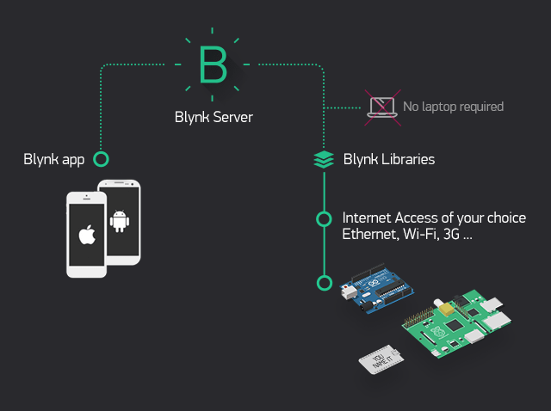

Figure 3. :Blynk cloud

## Logical design

The defining of the system's functions and characteristics is referred to as logical design. It describes the system's components and their interrelationships with users. It's a design that's not dependent on the implementation.



# chapter four

# System implementation

## introduction

This chapter's purpose is to show how the project's software and hardware are implemented. This chapter also covers the testing of the project's various phases. It explains the procedures followed as well as the working philosophy employed.

## system requirements

The system requirements are required to run the proposed system. It is important to have a few measures in place to ensure the smooth running of the system before the system is previewed. Web applications generally mostly have issues with browsers, especially the outdated ones. However, for a smoother experience while using the platform, the hardware and software requirements described in this section should be met.

### Hardware requirement

* ESP8266
* Sensors (Temperature, Humidity, Light Intensity, Soil Moisture)
* Breadboard
* Cables
* Processor (CPU) with 1.0 gigahertz (GHz) clock speed or above
* A minimum of 2GB RAM
* Minimum of 25GB disk space
* Internet connection broadband with 4Mbps speed or higher

### Software requirement

* An operating system [Windows android emulator/Android]
* Internet connection
* Blynk application

## implementation tools used

The different programming languages, Integrated Development Environments, and debuggers used to create the application are referred to as the software and hardware implementation tools. The tools used to implement the smart farm monitoring system include.

* C++
* Blynk application
* Arduino code
* Blynk libraries
* Arduino IDE
* Hardware sensors
* ESP8266 microcontroller

### C++

C++ is an object-oriented computer language created by notable computer scientist Bjorne Stroustrop as part of the evolution of the C family of languages. C++ is pronounced "see-plus-plus." It was developed as a cross-platform improvement of C to provide developers with a higher degree of control over memory and system resources. . The majority of the data types (array, bool, char, float, and so on) are C++ like. You can also conduct type conversion. Structure is the last section of the Arduino language. Small code elements, such as operators, are included.

### Arduino code

Arduino code is written in C++ with an addition of special methods and functions. C++ is a human-readable programing language. When you create a ‘sketch’, it is processed and compiled to machine language.

### Blynk application

Blynk is an app edit that connects and controls sensors and microcontrollers over the Internet. It’s a digital dashboard where you can build a graphic interface for your project by simply dragging and dropping widgets.

### Blynk libraries

With Blynk Library you can connect over 400 hardwaremodels (including ESP8266, ESP32, NodeMCU, all Arduinos, Raspberry Pi, Particle, Texas Instruments, etc.) To the Blynk Cloud. It is imported into the arduino code.

### Arduino Integrated Development Environment (IDE)

The Arduino IDE is the main text editing program used for arduino programming. It is where the code will be typed before uploading it to the board. Arduino code is referred to as sketches.

### Hardware sensors

Sensors are the most critical hardware in IoT applications and are used to gather information from the surroundings. These sensors include, light intensity, humidity, soil moisture and temperature.

### ESP8266 microcontroller

ESP8266 is a series of low-cost, low-power system on a chip microcontroller with integrated Wi-Fi and dual-mode Bluetooth.

## Analysis of the IoT Prototype Implementation

The IoT prototype is composed of an ESP8266 microcontroller, which accepts arduino IDE as the development interface and consist of sensors and environmental actuators. The prototype will be integrated with the blynk mobile IoT platform.

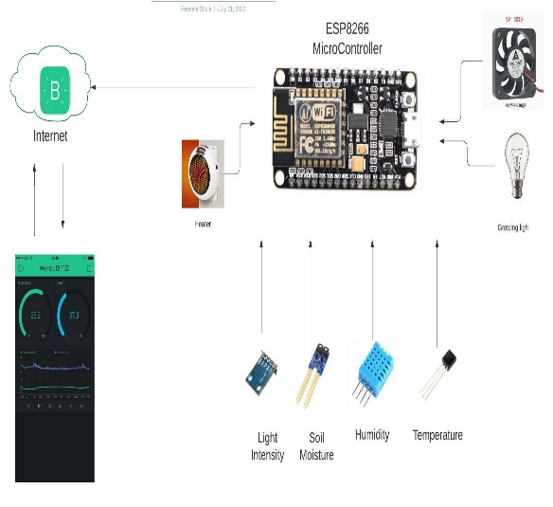

Figure 4. : IoT connection

### Performance and testing

The prototype testing strategies that were deployed were agile methods where testing was done concurrently with programming. The project had two phases where Phase 1 was developing the machine-to-machine communication while phase two was integrating with the blynk application. The respondents of the research, a greenhouse manager, was actively involved in each phase where testing was done in every iteration, and they validated each phase.

Phase 1 of the prototype development was setting up the board and sensors for data abstraction of environmental parameters. Development for this phase was done by programming the ESP8266 in C++ using Arduino software version 1.8.15. The testing of phase one was done in the Covenant University greenhouse to test efficiency of the machine-to-machine communication between the sensors and the ESP8266. The metrics for this phase were task time and success, the rate at which the sensors were recording environmental parameters and efficiency which was tested by the number of steps required to set up the board.

Table 4. 1: Temperature readings from sensors

|  |  |  |  |  |  |
| --- | --- | --- | --- | --- | --- |
| Crop type | Soil moisture | Humidity | Temperature | Light intensity | Time |
| Vegetable | 30% | 80% | 26°C | 400nm | 6:00pm |
| Vegetable | 35% | 80% | 27°C | 600nm | 8:00am |

This IoT prototype had the following strengths which make it a stronger architecture to be deployed in greenhouses: Monitoring environmental conditions in real-time which also enables real-time analysis to improve decision making by the greenhouse managers. This also optimizes agricultural processes in the greenhouse.

## program modules and interfaces

### Arduino IDE

An integrated environment for coding and uploading codes to the ESP8266

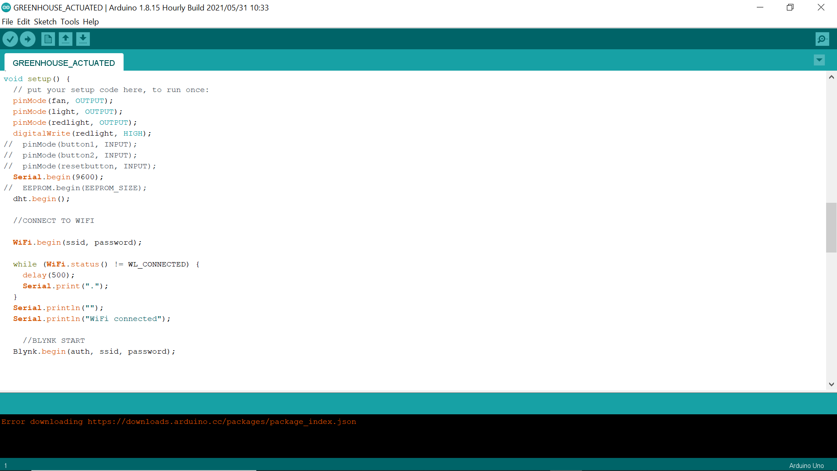

Figure 4. :Arduino IDE

#### Importing the libraries

To use the blynk application its libraries will have to be imported in the arduino code.

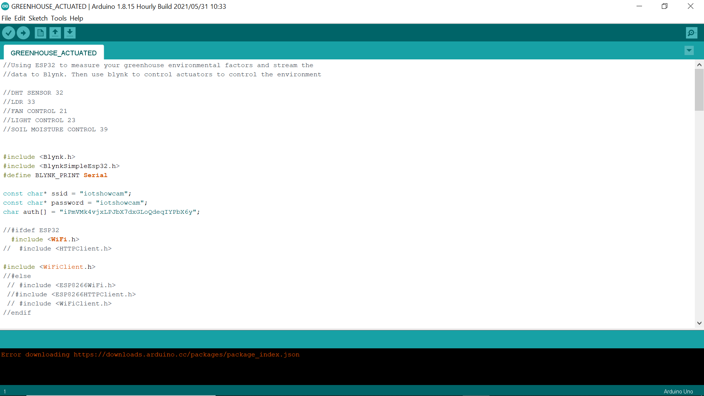

Figure 4. :Importing blynk libraries on the arduino IDE

#### Setting up the network

A web client will have to be stated in the arduino IDE code for the microcontroller to be able to connect to the wireless network.



Figure 4. :Setting up network in arduino IDE

### Blynk application

The blynk application is used as a graphic user interface between the hardware and the cloud. It is used to view live data from the sensors and control the actuators on the board. It also requires a unique authentication code from the application to be in the arduino code.

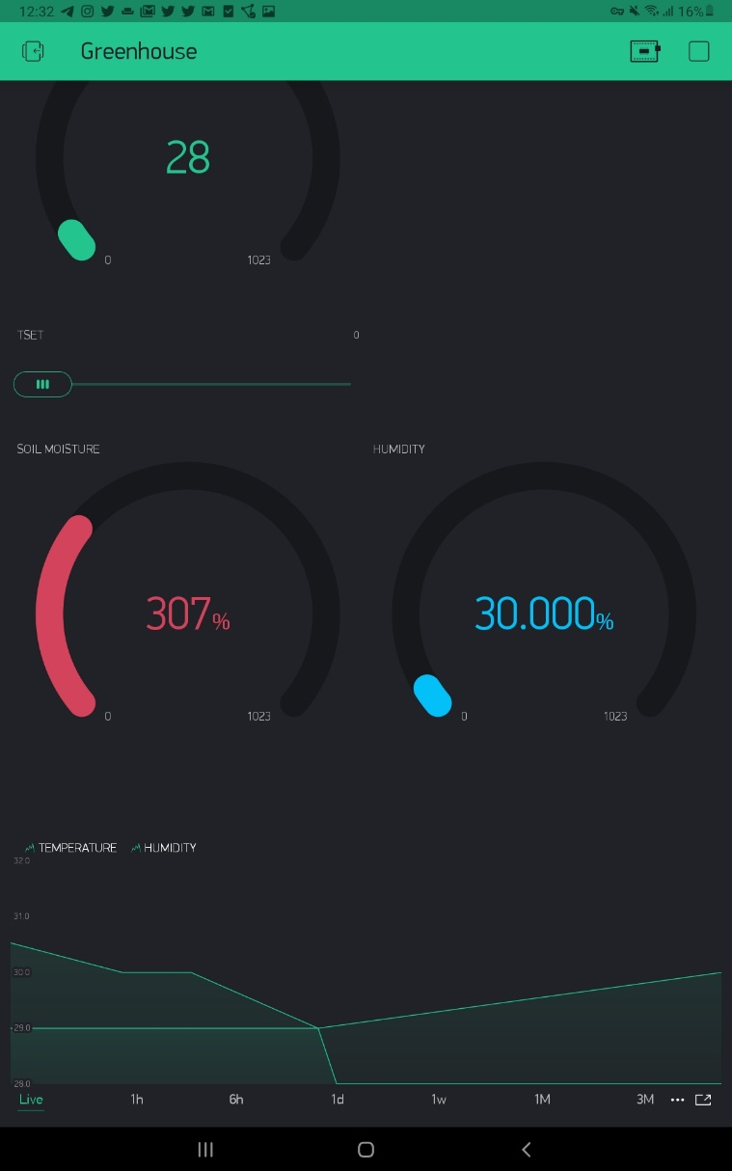

Figure 4. :Blynk IoT Application

# chapter four

# summary, conclusion and recommendation



## summary

The main goal of the study was to determine the ideal environmental conditions in a greenhouse and the best technology for monitoring those variables. The study included both primary and secondary data to meet its goals. The ideal climatic conditions in a greenhouse, as well as the problems experienced in greenhouse farming, were determined using primary data. Temperature, humidity, light, and carbon dioxide were discovered to be the most important environmental factors. The system designed will be used to monitor and control these conditions in the greenhouse to maximize crop production.

## conclusion

the obstacles experienced in greenhouse management were evenly distributed, with environmental conditions being the most critical issue. Farmers needed to react quickly to changing environmental circumstances to get greater yields.

## recommendation

Environmental conditions, among other elements such as water supplies, operating expenses, pests, and illnesses, have been identified as a critical necessity for ensuring greenhouse farming's success. As a result, IoT architectures should be used to monitor and manage a variety of environmental factors.

# references

FAO. (2013). *ICT Uses for Inclusive Agricultural Value Chains*. 1–69. http://www.fao.org/docrep/017/aq078e/aq078e.pdf

Grunwald, S., Thompson, J. A., & Boettinger, J. L. (2011). Digital Soil Mapping and Modeling at Continental Scales: Finding Solutions for Global Issues. *Soil Science Society of America Journal*, *75*(4), 1201–1213. https://doi.org/10.2136/SSSAJ2011.0025

Liu, S., Guo, L., Webb, H., Ya, X., & Chang, X. (2019). Internet of things monitoring system of modern eco-agriculture based on cloud computing. *IEEE Access*, *7*(c), 37050–37058. https://doi.org/10.1109/ACCESS.2019.2903720

López-Lozano, R., Duveiller, G., Seguini, L., Meroni, M., García-Condado, S., Hooker, J., Leo, O., & Baruth, B. (2015). Towards regional grain yield forecasting with 1km-resolution EO biophysical products: Strengths and limitations at pan-European level. *Agricultural and Forest Meteorology*, *206*, 12–32. https://doi.org/10.1016/J.AGRFORMET.2015.02.021

Maina, K. J. (2016). *Internet of Things for Monitoring Environmental Conditions in Greenhouses : A Case of Kiambu County*.

Ray, P. P. (2017). Internet of things for smart agriculture: Technologies, practices and future direction. *Journal of Ambient Intelligence and Smart Environments*, *9*(4), 395–420. https://doi.org/10.3233/AIS-170440

Saiz-Rubio, V., & Rovira-Más, F. (2020). From smart farming towards agriculture 5.0: A review on crop data management. In *Agronomy* (Vol. 10, Issue 2). https://doi.org/10.3390/agronomy10020207

Shen, Y., Wei, R., & Xu, L. (2018). Energy consumption prediction of a greenhouse and optimization of daily average temperature. *Energies*, *11*(1). https://doi.org/10.3390/en11010065

Shirsath, P. D. O., Kamble, P., Mane, R., Kolap, A., & More, P. R. S. (2017). IOT Based Smart Greenhouse Automation Using Arduino. *International Journal of Innovative Research in Computer Science & Technology*, *5*(2), 234–238. https://doi.org/10.21276/ijircst.2017.5.2.4

Systems, E. (2020). ESP8266EX Datasheet. *Espressif Systems*, 31. https://www.espressif.com/sites/default/files/documentation/0a-esp8266ex_datasheet_en.pdf

Tzounis, A., Katsoulas, N., Bartzanas, T., & Kittas, C. (2017). Internet of Things in agriculture, recent advances and future challenges. In *Biosystems Engineering* (Vol. 164, pp. 31–48). Academic Press. https://doi.org/10.1016/j.biosystemseng.2017.09.007

Varone, M., Mayer, D., & Melegari, A. (2019). *What is Machine Learning? A definition - Expert System*. Expert System.

Verdouw, C., Wolfert, S., & Tekinerdogan, B. (2016). Internet of things in agriculture. *CAB Reviews: Perspectives in Agriculture, Veterinary Science, Nutrition and Natural Resources*, *11*(December). https://doi.org/10.1079/PAVSNNR201611035

World, C. (2015). *THE INTERNET OF THINGS :* *October*.